
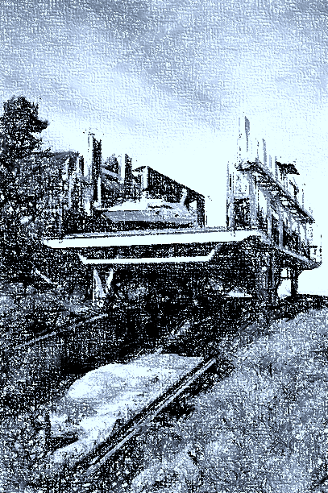

BIG CHUTE CLASSICS
all served with fries

THE BIG CHUTE BURGER
A local favorite for over 35 years
just local Hewwit beef, salt & pepper - on a toasted brioche bun
bacon, cheddar, shredded lettuce, field tomato, onion & pickle
24.95

NATURE BURGER
“Beyond Beef” burger
shredded lettuce, fresh field tomato, onion & pickle
19.95

BIG CHUTE FISH SANDWICH
Our beer battered haddock filet with cheddar cheese, tartar sauce and coleslaw - on a toasted brioche bun
22.95

BIG CHUTE FISH & CHIPS
Beer batter haddock fillet, coleslaw, lemon & tartar sauce
1 pc. 22.95 / 2 pc. 28.95

TRIPLE DECKER CLUBHOUSE
Grilled & chilled chicken breast, bacon, lettuce, fresh field tomatoes
and cheddar on toasted rye or white – served with mayo
19.95

FINGERS & FRIES
Breaded chicken tenders – bbq, sweet&sour, plum or honey garlic
18.95

(Gluten free bun available add $2)
SALADS AND HANDHELD

TRADITIONAL CAESAR SALAD
Crispy bacon, croutons & shredded asiago
18.95

CHICKEN CAESAR SALAD
Diced chicken breast, crispy bacon, croutons & shredded asiago
22.95

GARDEN SALAD
Romaine, tomato, cucumber, peppers
with your choice of honey basil, snappy garlic or cilantro lime dressing
18.95

KELLY’S FAMOUS TACO SALAD
Taco spiced chicken breast,
quesadilla veg & crispy romaine – topped with shredded cheese and Cilantro Lime dressing in fresh tortilla bowl
24.95

STEAKHOUSE STYLE WEDGE SALAD
Iceberg lettuce, crumbled blue cheese, crispy bacon, and seasoned tomatoes – with blue cheese dressing.
20.95 add “grilled and chilled” chicken 24.95

CHICKEN CAESAR WRAP
Crispy Chicken, romaine, bacon bits and fresh parmesan in a
flour tortilla
19.95
CHICKEN BRUSCHETTA “PANINI”
grilled chicken breast, bruschetta marinated tomatoes & smoked mozzarella cheese on a grilled ciabatta - basil mayo for dippin
20.95

NOSHABLES

MINI CORN DOGS
With a trio of dipping sauce, dill pickle ranch/ creamy honey mustard/ chipotle.
16.95

COCONUT SHRIMP
Marmalade & horseradish dipping sauce
18.95

A POUND OF CHICKEN WINGS
Hot, medium, honey garlic or Cajun
veggies & blue cheese dip
19.95
HOMEMADE BRUSCHETTA
using local field tomatoes from Freskiw’s in Coldwater
topped with crumbled feta & balsamic glaze
15.95
VEGETABLE QUESADILLA
Peppers, red onion, black beans & grilled local corn
salsa & sour cream
18.95

CHICKEN QUESADILLA
We took our veggie quesadilla and stuffed it with grilled chicken
21.95

DEEP FRIED PICKLES
With ranch for dippin
14.95

CLASSIC POUTINE
Real cheese curds & gravy
15.95
BUFFALO CHICKEN POUTINE
our traditional poutine topped with chopped & sauced tenders and drizzled with ranch
19.95
THICK CUT ONION RINGS
With chipotle mayo for dippin
13.95

BASKET OF FRIES
With a side of basil mayo for dippin
10.95

Big Chute restaurant
Summer Menu
DRINKS
Coffee or tea 2.50
Milk or Chocolate Milk 3.50
Pop .2.50
Coke, Diet Coke, Sprite, Ginger ale, Root Beer

Juice 3.00
Orange, Apple, Pineapple, Iced Tea, Lemonade

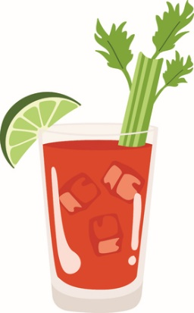
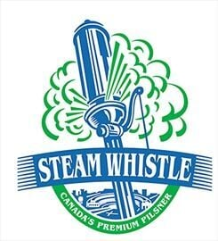
Liquor
Regular 1oz……………..7.75
Premium 1oz……………..8.75
Scotch, Gin, Vodka, Rum, Rye, Tequila
Liqueur
Regular 1oz
Grand Marnier, Brandy, Baileys, Kahua
6.75

Wine
Red - Cabernet Sauvignon & Merlot
6oz glass……..9.50
8oz glass….13.00
Bottle……32.00
White - Pinot Grigio, Chardonnay
& Sauvignon Blanc
6z Glass…….9.50
8oz glass….13.00
Bottle…….29.00

From the Bar
Domestic Beer 6.75
Premium & import 7.75
Steamwhistle Draft 9.95
Quayle’s Brewery (ask your server)
*Caesers* 12.95
Coolers 8.95
Cider 8.95

