
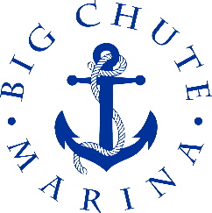
Big

Restaurant
Chute

ALL BREAKFAST INCLUDES COFFEE (FREE REFILLS), home fries or
tomato slices and toast

TWO EGGS ANY STYLE with bacon or sausage
14.95

Eggs Benedict
Two toasted English muffins toppe with Back Bacon, poached eggs and Hollandaise sauce.
15.95

BIG CHUTE MUFFIN
Egg, cheese and bacon or served on an English muffin.
14.95

B.L.T
Served with home fries
14.95

TOASTed WESTERN SANDWICH
Served with home fries
14.95

THREE EGG OMELETTES-******

Western……………………………………………………………………………………………………15.95
Three eggs, bacon, onions and green peppers served with home fries or tomato slices and toast

CHEESE OR VEGGIE……………………………………………………………………………………14.95
Three eggs with cheese or seasonal veggies served with home fries or tomato slices and toast

Greek……………………………………………………………………………………15.95
Three eggs with tomatoes, peppers, onions, black olives and feta

PANCAKES WITH BUTTER & SYRUP
12 .95

Menu
SERVED UNITL 12 p.M. SUNDAYS ONLY Breakfast

